The Problem — Shallow Pullbacks
In standard wave logic, an entry is only triggered when price pulls back to touch the 9 EMA Low (in uptrend) or 9 EMA High (in downtrend). However, there are situations where price makes a shallow pullback — it does not reach the EMA band — and continues in the trend direction. In such cases, the standard HH/HL logic never triggers and the trade opportunity is missed.

The Solution — Fractal Method
To capture shallow pullback entries, the strategy introduces the 3-Candle Fractal combined with the 20 SMA.

Fractal
What is Fractal ?
A Fractal is a 3-candle pattern that identifies a local High or Low on the chart. The middle candle (Candle 2) is the key — it just needs to have the most extreme high or low among the three candles. The candle type does not matter — it can be a doji, bullish, bearish, or any other candle.

Fractal Structure
- 1 candle on the left
- 1, 2 or 3 candles in the middle
- 1 candle on the right

Bullish Fractal (Bottom):
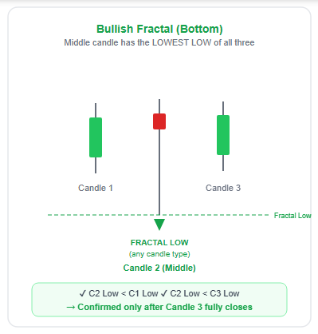

Rules for Bullish Fractal
C2 High > C1 High
C2 High > C3 High
C2 marks a Fractal High

Bearish Fractal (Top):
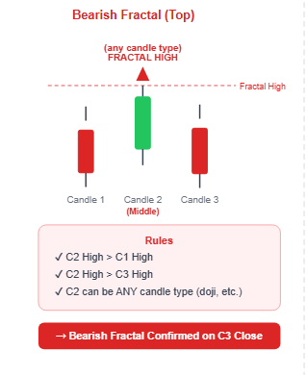

Rules for Bearish Fractal
C2 High > C1 High
C2 High > C3 High
C2 marks a Fractal High
Fractal + 20 SMA + EMA — Downtrend:
Core Condition:
- Candles must be below 20 SMA → confirms we are in downtrend
Fractal High (Swing High) is valid if middle candle of fractal is in ANY of these 3 zones:
- Middle candle just touches 9 EMA High or 9 EMA Low → Valid Fractal High
- Middle candle is in between 9 EMA High and 9 EMA Low (inside the band) → Still valid
- Middle candle is above 9 EMA High → Still valid in some cases
The KEY rule throughout all cases:
- Price / candles must remain below 20 SMA
- Fractal 3 candle pattern must form
- Then we consider it as a Lower High and plan short entry

FIB LEVELS AND ITS IMPLICATIONS FOR DOWNTREND
- Fib is drawn from Bottom to Top (HL to HH) — meaning 0 = HL and 1 = HH
- Entry — when price comes back down after the pullback
- -0.236 level — acts as Trap Zone (false moves happen here, avoid entry)
- -1 level — First Target with a slight deviation of ±0.01
- -1.618 level — Target 2
- SL — placed at the Fractal High

EDGE CASES
- SHALLOW TOUCH
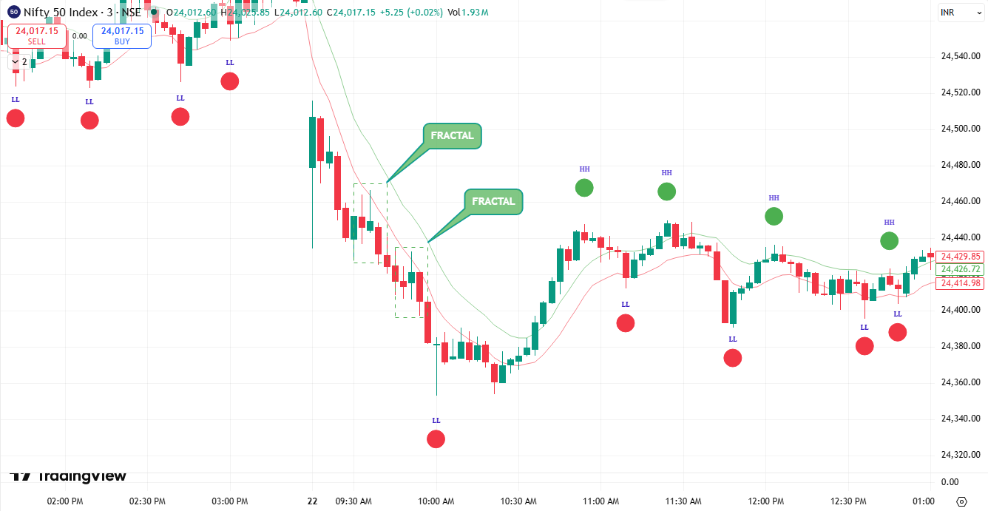
The Situation:
- In an uptrend, price pulls back but only touches 9 EMA High without closing below 9 EMA Low — then continues upward
- In a downtrend, price pulls back but only touches 9 EMA Low without closing above 9 EMA High — then continues downward
The Problem:
- Since price never crosses the opposite EMA band, the standard HH/HL marking rule never triggers — resulting in a missed trade opportunity even though the trend is clearly continuing in its original direction
In Uptrend:
- Price touches 9 EMA High → pulls back slightly → continues up
- No HL or HH is marked → no entry signal generated
In Downtrend:
- Price touches 9 EMA Low → pulls back slightly → continues down
- No HL or HH is marked → no entry signal generated
The Solution — Fractal Logic:
In such cases we shift to the Fractal method to identify the swing point:
In an uptrend — if price only touches 9 EMA High and a Bullish Fractal forms during the shallow pullback → the Fractal Low is marked as a valid Higher Low (HL) → plan buy entry
In a downtrend — if price only touches 9 EMA Low and a Bearish Fractal forms during the shallow pullback → the Fractal High is marked as a valid Higher High (HH) → plan short entry

- BIG CANDLE FORMS BETWEEN TWO EMA’S
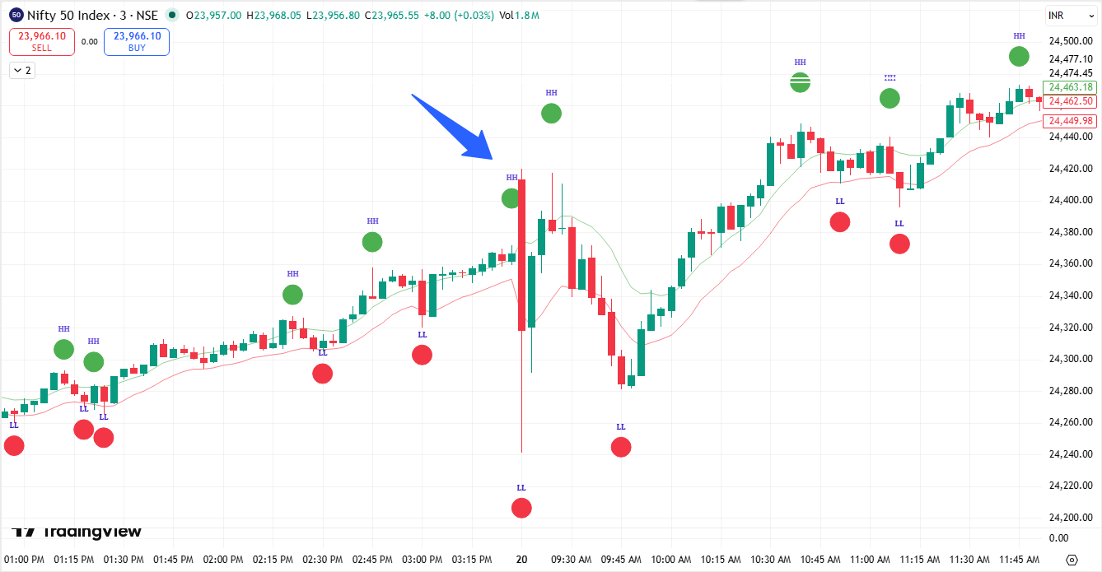

The Situation:
- In an uptrend, a single large candle forms which touches both 9 EMA High and 9 EMA Low in one move — creating confusion about direction
- In a downtrend, same situation — one big candle sweeps through both EMA bands leaving the trader directionless
The Problem:
Since the same candle touches both EMA High and EMA Low, the standard rules break down:
- We cannot clearly mark it as HH or HL
- The candle has already satisfied both conditions simultaneously
- It leaves the trader completely directionless — unsure whether to treat it as a continuation or reversal signal
- Results in a missed trade or wrong entry
In Uptrend:
- One big candle touches 9 EMA High and closes below 9 EMA Low in same move
- Cannot determine if this is a valid HL or a trend reversal → no clear entry signal
In Downtrend:
- One big candle touches 9 EMA Low and closes above 9 EMA High in same move
- Cannot determine if this is a valid HH or a trend reversal → no clear entry signal

The Solution:
- Wait for the next candle (or ongoing candle) to close above the big fat candle high (for uptrend) or close below the big fat candle low (for downtrend)
- Once that close is confirmed → wait for a pullback
- The high of the candle that closed above the fat candle = Entry level for long
- The low of the candle that closed below the fat candle = Entry level for short
- When price pulls back and comes back to that level → take entry
In Uptrend:
- Big fat candle forms → next candle closes above fat candle high → wait for pullback → fat candle closing candle's high = buy entry trigger
In Downtrend:
- Big fat candle forms → next candle closes below fat candle low → wait for pullback → fat candle closing candle's low = sell entry trigger

- Consolidation Zone (Price Trapped Between Both EMAs)
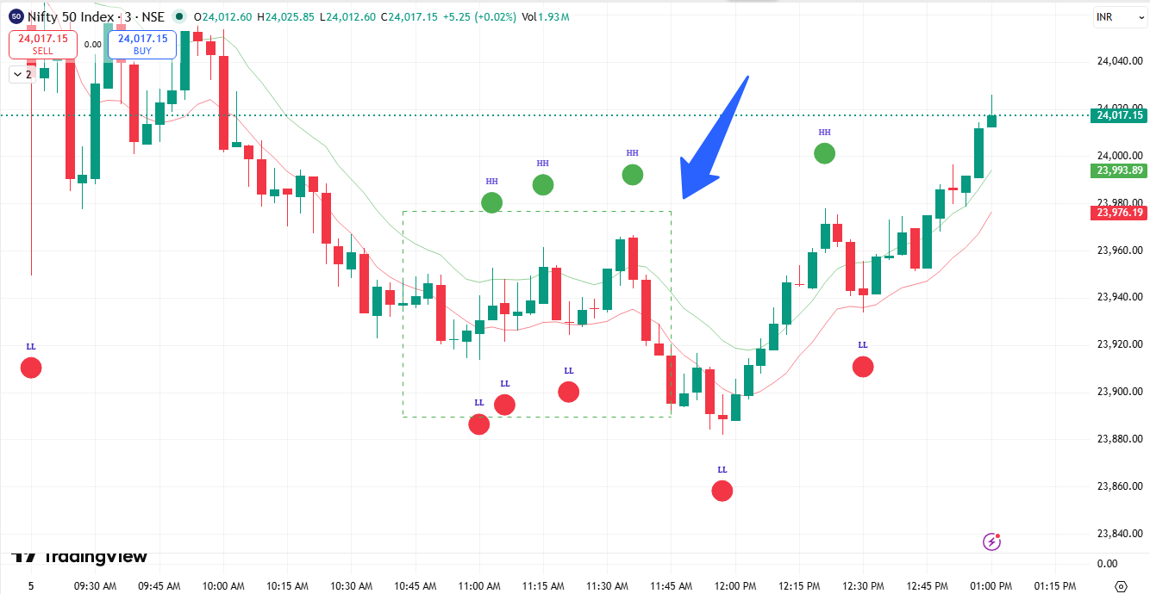

The Situation:
- Price enters a sideways consolidation phase where it repeatedly touches both 9 EMA High and 9 EMA Low with wicks on both sides
- Neither buyers nor sellers are in control — price is just oscillating within the EMA band
- This happens in both uptrend and downtrend before a breakout occurs
The Problem:
Since price is constantly touching both EMAs:
- HH and LL are being marked repeatedly on both sides
- Every touch of 9 EMA Low looks like an HL → signals a buy
- Every touch of 9 EMA High looks like an HH → signals a short
- Both signals are firing simultaneously creating complete confusion
- Taking any entry here leads to whipsaw trades and losses
In Uptrend:
- Price consolidates between both EMAs after an upward move
- Multiple false HH and HL signals generated → no clear direction
In Downtrend:
- Price consolidates between both EMAs after a downward move
- Multiple false HH and LL signals generated → no clear direction

The Solution — Candle Count Filter
Consolidation Identification Rule
- If a new HH-HL or LH-LL structure forms within the next 4 candles from the previous swing formation, the market will be considered sideways or consolidating
- Rapid wave formation indicates lack of wave expansion and weak momentum
- During this condition, no trades should be taken

Defining the Consolidation Zone
Once consolidation is identified:
- Mark the highest point formed inside the consolidation area
- Mark the lowest point formed inside the consolidation area
These two levels define the Consolidation Range.
Consolidation Boundaries
Highest Point → Upper Consolidation Boundary
Lowest Point → Lower Consolidation Boundary
- As long as price remains inside this range, the market will be treated as sideways.
- No new trades should be taken inside the consolidation zone.

Breakout Confirmation Logic
Bullish Breakout
- If any candle closes above the Upper Consolidation Boundary, the consolidation is considered resolved on the upside
- This indicates bullish momentum returning to the market
- After the breakout, the strategy resumes normal bullish wave logic
- Future HH and HL formations can again be considered valid for long opportunities

Bearish Breakout
- If any candle closes below the Lower Consolidation Boundary, the consolidation is considered resolved on the downside
- This indicates bearish momentum returning to the market
- After the breakout, the strategy resumes normal bearish wave logic
- Future LH and LL formations can again be considered valid for short opportunities

